 **REPORT**

**BUSINESS INTELLIGENCE AND DATA VISUALIZATION**

**Makeover Monday**

**MADE BY:-RISHABH SAINI (18CSU172)**

**Donut Chart**

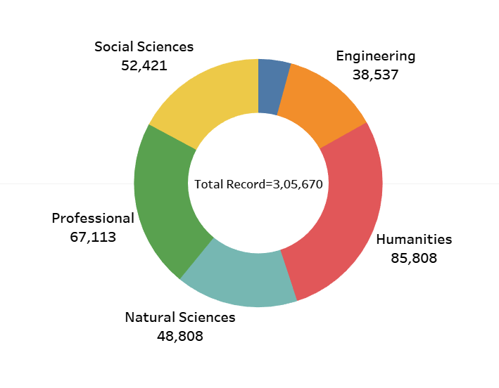

**Line Chart**

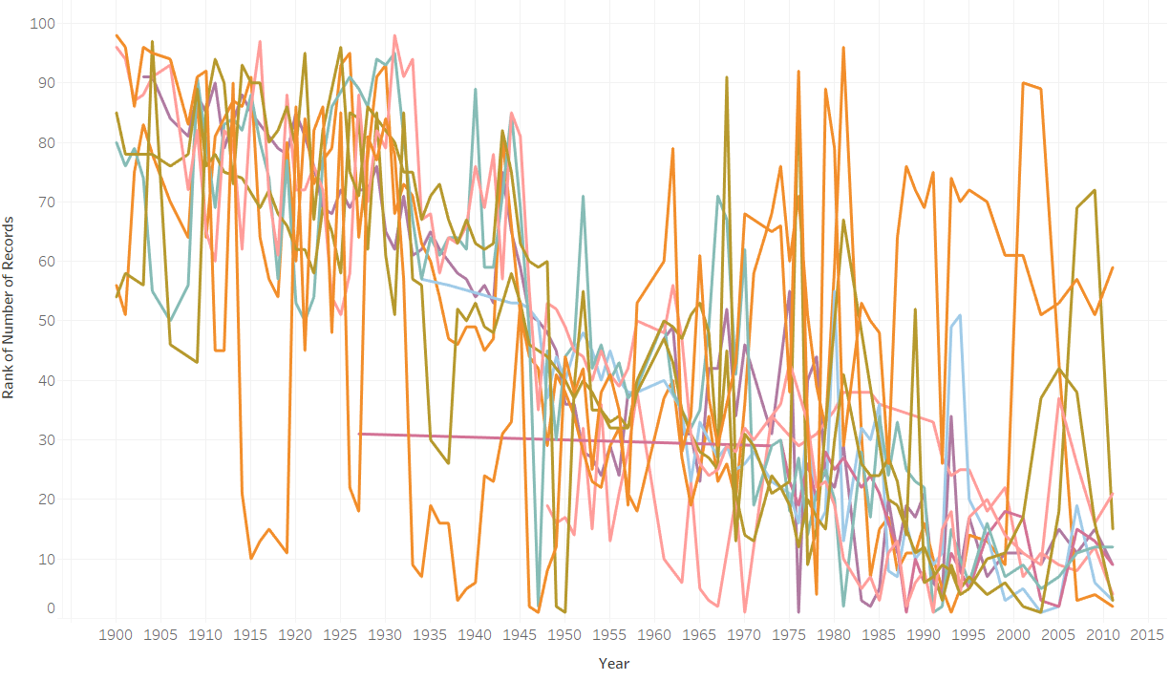

**Word Cloud**

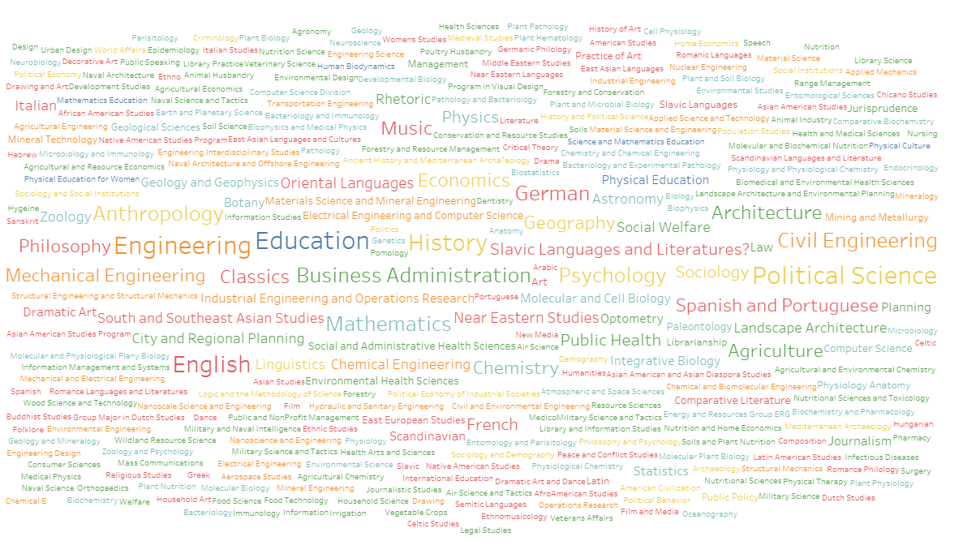

**Area Chart**

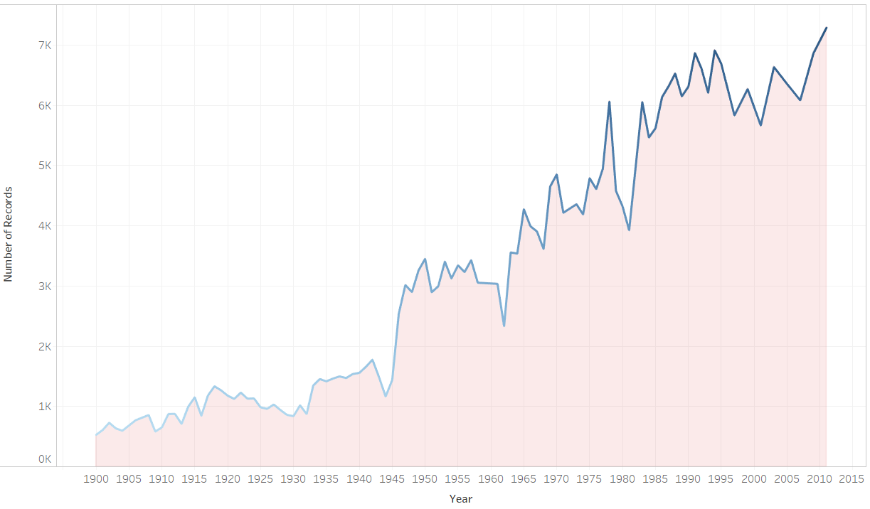

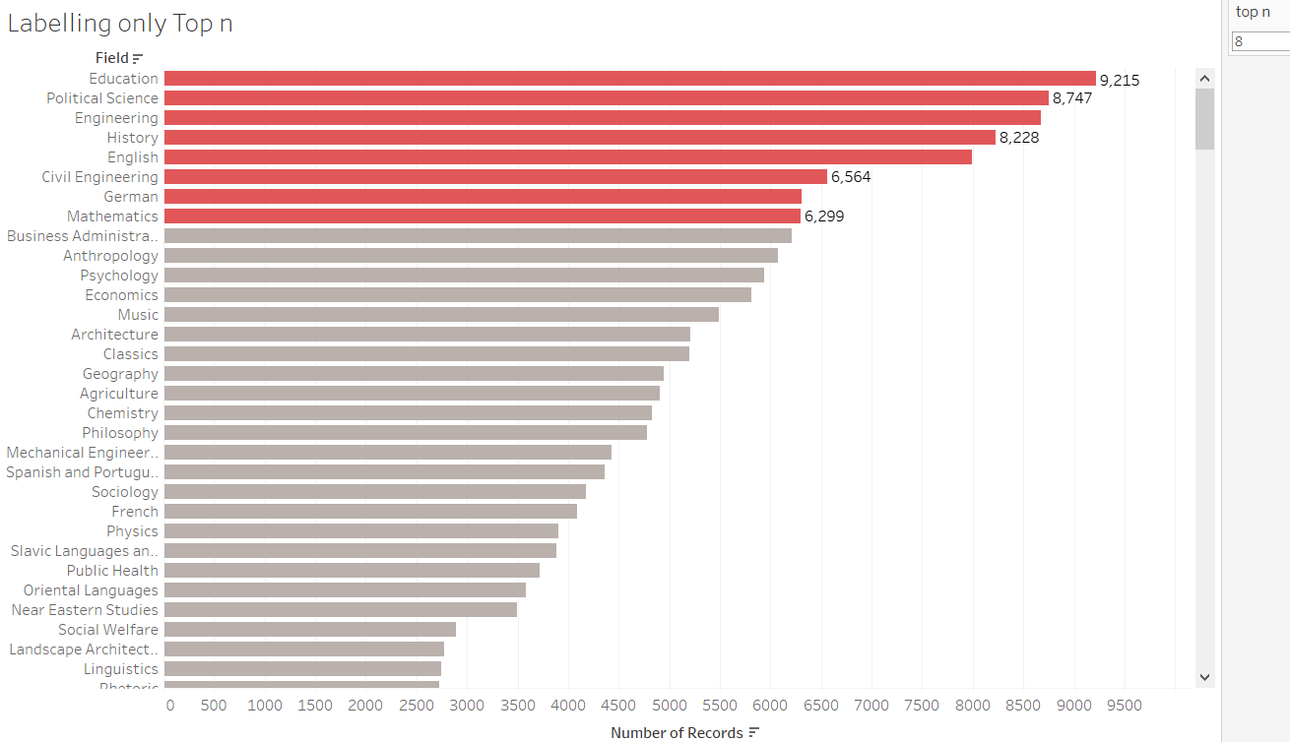**Labelling Top n Chart**